Lesson 1 Notes and Vocabulary –
Directions: Using the Lesson 1 PowerPoint and MOAC Lesson 1 E-book, answer the following questions and complete the vocabulary.
Part 1: Label the following terms on the screen shot below:
- Quick Access Toolbar (QAT)
- Ribbon
- Horizontal Ruler
- Insertion Point
- Status Bar
- Zoom Slider
- Tabs
- Document Title
- Group
- Collapse the Ribbon
To label a specific area on the ribbon follow these directions:
- Choose insert at the top and click on shapes
- Choose an arrow
- Click on the area in which you want to point to within the screenshot below
- Size the arrow you are creating to the size you want
- Once you have created an arrow, click on text box within the insert tab
- For each of the arrows draw a text box and label the arrow once the text box is drawn.
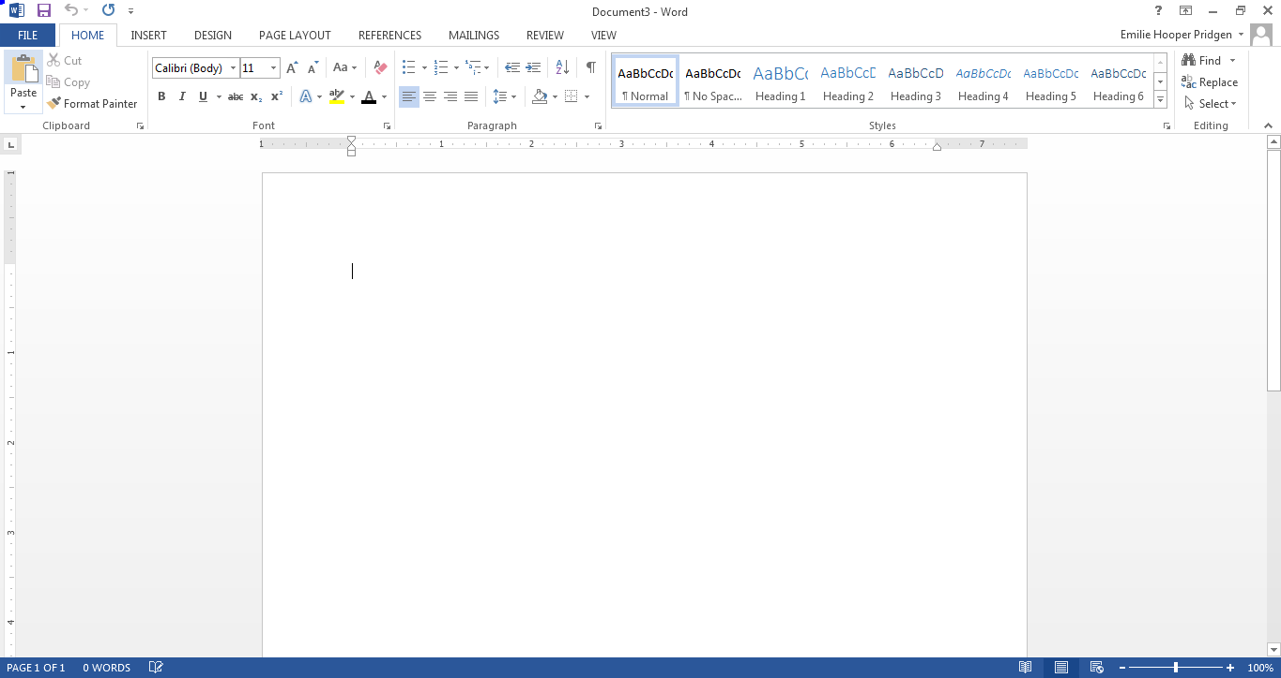

Part 2: Define the following terms using the MOAC Lesson 1 E-book:
AutoComplete
Backstage View
Block Style
Command
Dialog box
Dialog box launcher
Groups
Insertion Point
Menu
Mini Toolbar
Non-printing characters
Quick Access Toolbar
Ribbon
Shortcut Menu
Tabs
Template
Undo
White Space
Word Wrap

Part 3: Lesson 1 Certification Skills: Using the e-book, answer the following questions.
- How do you customize the Quick Access toolbar?

- How would you turn on the Show/Hide command?

- How do you create a new document?

- How do you save a document in a new file format?

- How do you create a document using a template?

- How do you set print scaling?

Part 4: Answer the following multiple choice questions.

- When you place your cursor over the insertion point, to what shape does it change?
a) dash
b) I-beam
c) box
d) underscore

- The Ribbon contains multiple __________ with common commands grouped on each.
a) icons
b) dialog boxes
c) buttons
d) tabs

- You cannot seem to locate a specific command while formatting text using commands in the Font group on the Home tab. Where can you find the dialog box launcher, which is necessary to display the dialog box with all commands?
a) upper left
b) lower left
c) upper right
d) lower right

- What displays when you point to selected text, allowing you access to popular commands?
a) drop-down menu
b) Mini toolbar
c) shortcut menu
d) dialog box

- In order to save time searching for common commands, you can add tools to which toolbar located above the Ribbon?
a) Menu Toolbar
b) Word Toolbar
c) Shortcut Toolbar
d) Quick Access Toolbar

- Which button on the Quick Access Toolbar can you use to cancel your last command or action?
a) Redo
b) Undo
c) Delete
d) Cancel

- Which tab displays Backstage view?
a) Home
b) File
c) View
d) Page Layout

- Which of the following options are available in the Info group on Backstage?
a) Mark document as final
b) Print document
c) Password protect document
d) Check compatibility
e) Share document

- Which of the following options are available in the Print group on Backstage?
a) Choose number of copies
b) Choose default printer
c) Set printer properties
d) Preview document
e) Save as PDF

- What Word feature reduces the amount of time spent typing common content or phrases in a document?
a) AutoComplete
b) AutoInsert
c) Insert
d) AutoFill

- Which of the following Word options are available when saving the document as a different file type?
a) Word template
b) web page
c) Rich Text Format
d) PDF
e) XLS

- Which of the following extensions applies to a Word 2013 document?
a) *.docx
b) *.doc
c) *.dotx
d) *.dot

- You no longer need to share your document with others using an earlier version of Word. Which option in Backstage can you use to deactivate Compatibility Mode and save the file in Word 2013 format?
a) Revert
b) Upgrade
c) Convert
d) Save

- On which tab will you find the Print options?
a) Home
b) File
c) Review
d) Insert

