Tab / Group Exercise
Directions: For each item below, write which tab and group the commands can be located on.
- 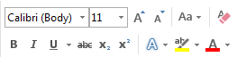Tab: ______________ Group: __________________

- 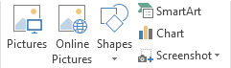 Tab: ________________ Group: ___________________

- 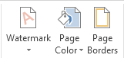 Tab: ___________________ Group: __________________________

- 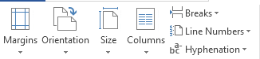 Tab: __________________ Group: _________________

- 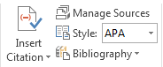 Tab: ___________________ Group: _______________________

- 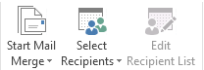 Tab: ______________ Group: ________________________

- 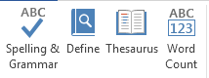 Tab: _____________ Group: ___________________________

- 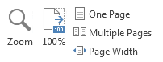Tab: ________________ Group: ___________________

- 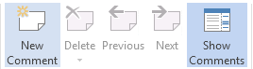Tab: ____________________ Group: ______________

- 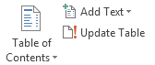 Tab: __________________ Group: _____________________

- 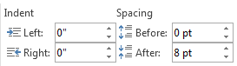Tab: ___________ Group: _______________

- 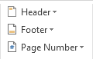

- 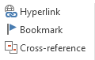 Tab: __________________ Group: ___________

- 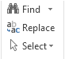 Tab: __________________ Group: _____________________

- 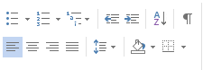 Tab: _________________ Group: ________________

- Tab: _______________________ Group: _________________________

- 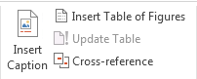 Tab: _________________ Group: _______________________

- 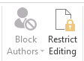 Tab: _________________ Group: _________________________

- 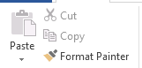 Tab: ________________ Group: ____________________

- 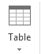 Tab: ___________________ Group: __________________

- 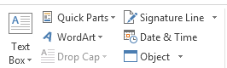 Tab: ________________ Group: _______________________

- Tab: ____________ Group: _________________

- 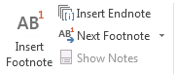 Tab: __________________ Group: ______________________

- 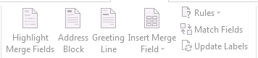 Tab: _________________ Group: ______________

- 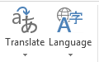 Tab: ____________________ Group: __________________________

- 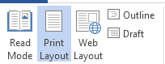 Tab: __________________ Group: ______________________

- 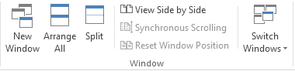 Tab: _______________ Group: _____________

- 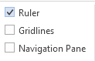 Tab: ______________ Group: ___________________________

