POB 4.01-4.03 Exam Review WS Name: Date:

- Explain the terms revenue, expenses, profit, and loss.

- What are the 4 steps in planning a budget?

- Identify and describe the 3 types of budgets.

- Explain the difference between assets and liabilities.

- What information is recorded on a balance sheet?

- What information is recorded on an income statement?

- Complete the chart below with the formula and what information the ratio provides a business.
CURRENT RATIO | DEBT TO EQUITY RATIO
RETURN ON EQUITY RATIO | NET INCOME RATIO

- Explain the difference between a deposit institution and a non-deposit institution.

- Identify the 4 types of deposit institutions.

- Identify the 6 types of non-deposit institutions.

- Identify and briefly describe the 5 factors affecting the selection of a financial institution.

- What is EFT? Where do we use EFT?

- Explain the difference between a payee, a drawee, and a drawer.

- Identify the 7 steps in the proper check writing procedure.

- Explain the difference between a certified check, a cashier’s check, a traveler’s check and a money order.

- Define endorsement.

- Explain the difference between a blank endorsement, a special (full) endorsement, and a restrictive endorsement.

- Identify the 6 steps in a bank reconciliation.

- What is the Federal Reserve System and why does it exist?

- Identify 7 functions/services provided by the Fed.

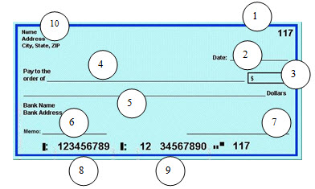

- Label the parts of a check.

- Explain the difference between saving and investing.

- Explain the difference between a savings account, a certificate of deposit (CD) and a money market account.

- Explain the difference between simple interest and compound interest. Include the formulas for both!

- What are dividends?

- Identify and briefly describe the two types of stocks.

- What is market value? Identify at least 2 factors that can affect market value.

- Identify the 4 steps in the stock selection process.

- What does yield mean?

- What is a price-earnings ratio and what does it tell you?

- What is a bond? Identify the 4 types and briefly describe each.

- What is a mutual fund?

- What does liquidity mean?

- What does APY mean?

- Define each of the following types of “alternative investments” – real estate, futures/commodities, and collectibles.

Complete Unit 4.00 Vocats Exam Practice on BB (you need at least a 27 out of 30)
Complete the assigned 4.01, 4.02, and 4.03 Quia Reviews – Linked on BB (you need at least 3 min. on each game)

