Word Lesson 6 Guided Notes

Part 1: When you insert a table, word gives you two contextual tabs to format the table. Label the following on the table tools contextual tab.

- Table Styles
- Borders
- Insert Rows
- Adjust Height and Width
- Alignment
- Sort

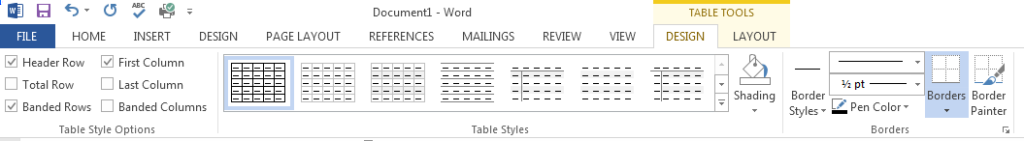

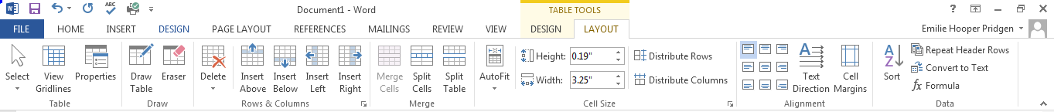

Part 2: Vocabulary

Ascending
Cells
Cell Range
Descending
Field Code
Formulas
Header Row
Merge Cells
Object Zoom
Quick Tables
Sort
Split Cells
Table

Part 3: Certification Skills

- How do you create a table using the dragging method?

- How do you create a table using the Insert Table Dialog Box?

- How do you create a customized table?

- How do you create a table using Quick Tables?

- How do you apply a style to a table?

- How would you adjust content in a table using AutoFit?

- How would you adjust column width?

- How would you adjust row height?

- How would you sort the data in a table?

- How do you merge cells?

- How would you convert text to a table?

Part 4: Multiple Choice:
1. Which of the following options does Word provide for creating a table?
a) table Drawing tools
b) dragging method
c) table text box
d) Insert Table dialog box
e) SmartArt
f) Quick Table method

2. Under which Word Menu Tab can you locate the Create Table option?
a) Home
b) Insert
c) Design
d) Page Layout
e) View

3. Which of the following options are available on the Insert Table dialog box?
a) Autofit to window
b) Auto fit to content
c) Number of columns
d) Fixed column width
e) Number of rows
f) Font color
g) Background color

4. What option do you select under Table Styles to have every other line shaded?
a) Striped
b) Banded Rows
c) Total Row
d) Banded Columns

5. In order to format the first column, which usually contains the column heading, which option do you select?

a) Header Row
b) First Column
c) Banded Columns
d) Last Column

6. What options or groups let you resize rows or columns?
a) Split Table
b) Cell Size Group
c) Ruler
d) Alignment
e) Data Group
f) Table Properties

7. What does the Alignment option on the Table Tools Table Properties dialog box adjust?
a) text in document
b) table position
c) cell content
d) both table and cells

8. How many options for aligning cell content are found in the alignment group?
a) 3
b) 9
c) 12
d) 15

9. When converting text into a table, at which characters can Word separate the selected text?
a) spaces
b) commas
c) paragraph marks
d) plus
e) tabs
f) other

10. What does the Alignment option on the Table Tools Table Properties dialog box adjust?
a) text in document
b) table position
c) cell content
d) both table and cells

