Word Lesson 7 Guided Notes

Part 1: Label the following on the Design Tab and fill in the blanks.

- Themes: Each theme uses a ________ set of colors, fonts, and effects to create a _____________ look and feel.
- Theme Colors: Quickly change all ________ used in your document by picking a _________ color palette.
- Theme Fonts: Quickly change the _______ in your document by picking a new __________ set.
- Theme Effects: Quickly change the ___________ look of ____________ in your document.
- Watermark: Add _____________ text such as “confidential” or “urgent” behind the _________ on your page.
- Page Color: Add a splash of ___________ to your document by changing the color of the _____________.
- Page Borders: Add or change the ______________ around the __________________.

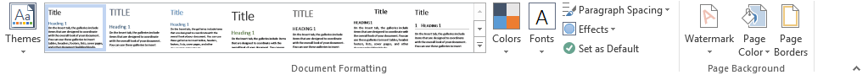

Part 2: Vocabulary

AutoText
Building Blocks
Document Theme
Drop Cap
Field
Pull Quote
Style Set
Text Box
Unicode
Watermarks

Part 3: Certification Skills

- How do you change a document’s theme?

- How would you create a customized color and apply it to a document?

- How would you create a customized font and apply it to a document?

- How would you create a customized effect and apply it to a document?

- How would you change a document’s style?

- How would you insert a watermark?

- How would you insert a custom watermark?

- How would you insert a special character in a document?

Part 4: On what tab and in which group do you accomplish the following tasks.

- Insert Special Characters: Tab____________ Group: ________________

- Create a Drop Cap: Tab______________ Group: __________________

- Format a Text Box: Tab______________ Group:_________________

- Insert the date and time: Tab______________ Group:_________________

- Insert an equation: Tab______________ Group:_________________

Part 5: Multiple Choice:

1. In theme colors, colors are included for which of the following?
a) hyperlink
b) text and background
c) border
d) accent
e) underline

2. Which of the following are the most common styles applied in a Word document theme?
a) Subtle Emphasis
b) Title
c) Heading 1
d) Heading 2
e) Body
f) Quote

3. Which of the following sets affects the whole document with predefined fonts and paragraph spacing?
a) Font
b) Format
c) Style
d) Layout

4. Which of the following options are available for page color background fill effect?
a) shading
b) gradient
c) texture
d) pattern
e) picture

5. Which of the following options are included on the Watermark Menu?
a) Picture
b) Language
c) Text
d) Font
e) Color
f) Size

