Word Lesson 9 Guided Notes

Part 1: Label and Fill in the blank.

- __________________the Spelling Pane.
- Finds the _____________ of a word
- A reference with ____________words used to ____________ for another word.
- Translates ____________ or paragraphs into a different language.
- Word provides the number of words, __________, and paragraphs used in a ________________.

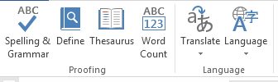

Part 2: Vocabulary:

All Markup
Antonym
AutoCorrect
Ballons
Inline
Lock Tracking
Markup
No Markup
Original
Person Card
Simple Markup
Synonym

Part 3: Label the following in the comments and tracking group.

- Insert a new comment
- Delete comment
- Show comments beside the document in the Person’s card.
- Simple markup is new for Word 2013 and is the default view.

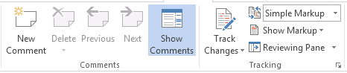

Part 4: Multiple Choice

- What kind of line designates a misspelled word?
a) wavy green c) wavy blue
b) wavy red d) straight yellow

- What kind of line designates a grammatical error?
a) wavy green c) wavy blue
b) wavy red d) wavy purple

- What kind of line designates words being used inappropriately?
a) wavy green c) wavy blue
b) wavy red d) wavy purple

- From the Spelling task pane, you can do which of the following?
a) Ignore All occurrences of an error
b) Change All occurrences of an error
c) Add word to Dictionary
d) Change Dictionary’s language
e) Undo previous changes

- How can you can locate the AutoCorrect options?
a) Review, Define
b) File, Options, Proofing
c) File, Options, General
d) View, Macro

